Action 10: Local Energy Demand and Resource Identification Methodology
Contents
1 Introduction 3
2 Energy Demand Methodology 4
2.1 Data Collection 5
2.2 Ratio Factors 6
2.3 Local Factors 7
2.3.1 Residential Example 7
2.3.2 Transport Example 7
2.4 Energy Demand Flowchart 9
3 Renewable Energy Source Methodology 11
4 Future Demand and RES Mapping Methodology 12
5 Overall Process Flowchart 15
6 Uncertainties & Data Assumption 16
7 Constraints and Opportunities 17
8 Job Creation Prospects of Renewable and Sustainable Energy Technologies 18
8.1 Method 18
8.2 Method Strands 18
8.2.1 Strand 1: Definitions, Categorisation and Harmonisation 19
8.2.2 Strand 2: Scoping 20
8.2.3 Strand 3 and 4; Methodology review and data collation 21
8.3 Results 21
8.3.1 Data collection 21
8.4 Job Creation Conclusions 22
9 Recommendations 23
10 References 24
Appendix I 27
Appendix II 28
Appendix III 29

Introduction

Many European regions are currently experiencing significant growth in unemployment and increased global energy prices. It is appropriate to look at the impact of renewable energy on employment. This is the central tenet of this paper as it aims to:
- Outline the methodology used to establish the current and potential, energy demand and Renewable Energy Sources (RES) within in a region.
- Review terminology and methods in the literature relevant to jobs created by renewable and sustainable energy technologies. It selects and adopts one of these methods and ads to its breadth and utility.
With these aims in mind the following objectives arise
- Establish local Energy Demand
  - Identifying and correct use of appropriate national and regional data/statistics
  - Determining pro-rate factors
  - Establishing and Evaluating local factors
  - Predicting future energy demand trends

- Determining RES Resource within the region
  - Quantify current local RES energy production
  - Researching future scenario
  - Model forecasted scenarios

- To understand the benefits of the job creation:
  - To outline job definitions, classifications and measurement units.
  - To initially scope a boundary including all jobs arising from these technologies.
  - To select an appropriate method that assesses the employment impacts of these technologies.
  - To collate comprehensive data on the job creation benefit of these technologies.
  - To correct the import imbalance wind technology places on Irish manufacturing jobs giving relevance to job location.

Energy Demand Methodology

In practice, there are two basic methodological approaches used to model the interactions between energy, economy and environment, the top-down approach and the bottom-up approach. The commonality of both of these approaches is their focus on analysing the impact of different policies. The main differences between top-down and bottom-up in essence they “differ mainly with respect to emphasis placed on a detailed, technologically based treatment of the energy system [bottom-up], and a theoretically consistent description of the general economy [top-down],” (Löschel, 2002). The top-down approach typically describes the energy system in an aggregated way and as a sub-sector of the entire economy, and the model results are mainly induced by relative price changes. Bottom-up (or systems engineering) models are designed to consider the energy sector in relatively great detail, and they do not include a complete model of economic activity (as is the case in top-down models)
The general approach used for this methodology is a combination of the two. The energy demand side utilised a top-down approach and RES generation being a mixture of the two. For demand, it involves taking national energy balance data and to proportion data down, using appropriate ratios, to the regional or local level. In Ireland, the Sustainable Energy Authority of Ireland (SEAI) gathers national energy consumption data for the Department of Communications, Energy and Natural Resources (DCENR). All energy imports are recorded by the state through the ports and the conversion of ‘Primary Energy’ into electricity is obtained from the National Electricity distributor (Electricity Supply Board (ESB) Networks in Ireland), who manage all sources of electricity being supplied into the Irish National Grid. In Ireland, SEAI also gathers data from other Government Departments and Agencies, energy suppliers and distributors. Based on this data they can determine, with some accuracy, the following information:
- Total Primary Energy Requirement (TPER)
- Electricity Generated
- Indigenous fossil fuel production (in Ireland Peat Briquette production)
- Indigenous renewable energy production
- Gross Final Consumption (GFC)
- Total Final Energy Consumption (TFEC)

Total Primary Energy Requirement (TPER): This is the total requirement for all uses of energy, including energy used to transform one energy form to another (e.g. burning fossil fuel to generate electricity) and energy used by the final consumer.
Total Final Consumption (TFC): is a measure of the energy that is delivered to energy end users in the economy to undertake activities as diverse as manufacturing, movement of people and goods, essential services and other day-to-day energy requirements of living.
Gross Final Consumption (GFC): the energy commodities delivered for energy purposes including the consumption of electricity and heat by the energy branch for electricity and heat production including losses of electricity and heat in distribution.
$$GFC=TFC\left(Transport\right)+GFC \left(ELec\right)+GFC(Heat)$$

Energy use can be categorised by its mode of application, that is, whether it is used for mobility (transport), power applications (electricity) or for thermal uses (space or process heating). Mode of application is use as the EU target documentation.
In Ireland, the National Energy Balance data is presented for the years 1990 to current year. The data is broken down into the following broad economic sectors: Industry, Residential, Transport, Commercial & Public and Agriculture. The sectors are further broken down into fuel type consumption. For other countries, a similar approach may be used, in addition to any relevant Eurostat data.
Specific information on data sources for the relevant sectors is provided in the following sections. This will refer to the ‘Ratio Factors’. Ratio Factors are the adjustment vehicles that are applied to the national data, to prorate down to appropriate regional data. Certain ‘local factors’ where appropriate are then exploited to create a more localised energy consumption.

Data Collection

Table 2-1 shows the typical data source used within the energy demand and the RES generation report.
Applicable Areas | Data Source | Source
Energy Balance | National Energy Balance Statistics | National Energy Agency, Dept. of Energy
Ratio & Local factors | Socio-economic statistics (Employment stats, House & Car ownership, Journey times, etc) | Central Statistics Office
Ratio factors | Land use statistics | Central Statistics Office
Energy balance & RES generation | National Energy Action Plans | Dept. of Energy
Energy balance & RES generation | Renewable Generation statistics in Ireland | National Energy Agency, RES Assn.
Future Trends | Energy forecasting Reports | National Energy Agency, RES Assn
Future trends | Energy Modelling statistics | National Energy Agency, RES Assn
Future trends | RES Potentials in Ireland | National Energy Agency, RES Assn
Energy balance & RES generation | Generators connected to Grid | Grid Operator and Regulator
Energy balance & RES generation | Bottom-Up RES generation data | Local Energy agency, Direct contact with RES companies.
Table 2-1 Typical Data used in Energy Balances

Ratio Factors
Ratio factors are the proportion adjustments that are used to distribute energy data from the national level, down to the regional level. Ratio factors are typically established by using the foremost/substantive facet within each economic sector, i.e. for agriculture it could be head of cattle or sheep.
The following ratios were discussed with the SEAI’s Statistical Support Unit has confirmed the suitability of the following ratios.

$$\text{Agriculture Ratio =}\frac{Total Farmed Land in local Region}{Nationally farmed Land}$$

$$\text{Commercial Ratio =}\frac{Number of Commerical Workers in local Region}{National Number of Commercial Workers}$$

$$\text{Residential Ratio =}\frac{Number of Private Houses in local Region}{National Number of Private Houses}$$

$$\text{Transport Ratio =}\frac{Number of Private Vehicles in local Region}{National Number of Private Vehicles}$$

$$\text{Industrial Ratio =}\frac{Number of Industrail Sector Workers in local Region}{National Number of Industrial Sector Worker}$$

The commercial and industrial sector’s energy consumption within the local region is assumed to be directly related to the level of energy used in this sector nationally, and the national figures are proportioned out based on the numbers employed within this sector, in the local region. For transport, the principal factor for Tipperary here is private car ownership, as public transport is insignificant, County Tipperary is a rural region with some small (< 10,000 people) towns, there is no dedicated public transport. All transport energy figures omit international aviation because these values are not included in the local energy balance as Tipperary doesn’t have an airport, it is acknowledged that this is attempting to focus on local use and impacts. For residential the salient factor was considered to be private house ownership. It is important that all countries and regions draw appropriate boundaries for what will be included or excluded from the regional energy balance. It is also paramount that all countries analysis their own energy uses within each sector to find those influential elements to construct the ratio factors.
An additional consideration when selecting these factors is to choose factors that is quantified frequently and from reputable sources. Typically the central statistics offices and government’s departments would have this data available on annual, biennial or triennial basis. The intervening years can be quantified by interpolation.

Local Factors
Local factors were investigated to establish a localising trend within each sector for the region. It was deemed that for the Industrial and Commercial sectors, local factors would be difficult to establish, that could be able to apply with any great level of accuracy. This is primarily due the flows of employment between Tipperary and the neighbouring regions would be problematic to calculate. For agriculture, it was felt that utilised farm land was the most appropriate local factor which is already used as the ratio factor.

Residential Example
One area investigated, utilised SEAI’s Building Energy Rating (BER) research tool, which is a database of all the BERs conducted nationally. The BER is Ireland’s solution to the EU Directive on the Energy Performance of Buildings (2002/91/EC of 16 December 2002). Employing this database, it was found that 22% of premises in Tipperary have had a BER, with 21% nationally, therefore statistically valid and robust data sets. As the region in question is rural, with lower density development than cities, it is appropriate to adjust the energy consumption on this basis. Table 2-2, shows that there is an 11% higher energy use for houses in Tipperary than the national average, therefore a factor of 1.11 is applied to the residential sector after the ratio factor has been applied.
 | Total Energy Used (kWh) | No. of BER | Census Housing Stock | BER proportion | Energy per House (kWh) | Difference
National | 9,042,384,291 | 332,287 | 1,649,408 | 20.1% | 27,212
Tipperary | 384,535,527 | 12,598 | 58,275 | 21.6% | 30,523 | 10.85%
Table 2-2 Residential BER Predicated Energy Use (SEAI, Sustianable Energy Authority of Ireland, 2012)

Transport Example
Transportation was also investigated using private vehicle registered for tax statistics within the region. In Figure 2-1, the dispersion of engine sizes regionally and nationally is shown. In Figure 2-2, the share of each tax bands is shown. Tax bands are based on CO₂/km. Tax bands based on CO₂/km has recently (2008) been adopted hence the need to show both sets of data, it is assumed that emissions levels would increase with engine capacity for the engine capacity analysis. Both graphs exhibited a similar trend nationally and for Tipperary. However, in Figure 2-3, we see that the duration of time to get to work is lower than the national average, probably due to lack of traffic delays being a rural region. This is 11% lower than the national average. Therefore a factor of 0.89 was applied to the transportation sector for the local region.

Figure 2-1 Engine Size Distribution (Dept.Transport, 2011)

Figure 2-2 Tax Band Distribution (Dept.Transport, 2011)

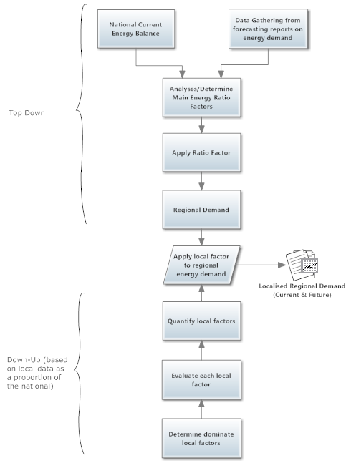
Figure 2-4 Work Travel Time (CSO, 2012)
Figure 2-3 Energy Demand Methodology Flowchart

Energy Demand Flowchart

In figure 2-4, the overall flow chart to achieve the energy demand side of the Energy balance is presented.
The first two processes considered within the flowchart is the gathering of national data on the current and future energy demands. Then the ratio factor is determined, explained in section 2.2. These factors are then applied which will give the top down regional energy demand.
For the bottom up section of the flowchart the local factors are determined first as outlined in section 2.3. Subsequently, they are evaluated to ascertain if they differ from the national trend and then quantified as a factor. The product of the regional energy demand and the local factors will produce the output which is the localised regional energy demand for both current and future.
Current and future energy demands can be completed in parallel or separate to each other but the over process and flows are the same for both. Table 2-3, demonstrations a sample example of the energy demand within the local region of Tipperary. In this, each economic sector is divided by fuel type.

Sector | Fuel Type | 2008 | 2009 | 2010
Industry | coal | 5.77 | 3.90 | 3.76
Industry | peat | 0.00 | 0.03 | 0.00
Industry | petroleum | 34.84 | 25.98 | 26.68
Industry | natural gas | 17.96 | 14.98 | 16.21
Industry | renewables | 4.86 | 4.84 | 5.29
Industry | electricity | 23.97 | 25.77 | 27.19
Industry | total | 87.41 | 75.51 | 79.13
Transport | coal | 0.00 | 0.00 | 0.00
Transport | peat | 0.00 | 0.00 | 0.00
Transport | petroleum | 151.27 | 136.59 | 126.39
Transport | natural gas | 0.00 | 0.00 | 0.00
Transport | renewables | 1.91 | 2.60 | 3.14
Transport | electricity | 0.17 | 0.14 | 0.14
Transport | total | 153.35 | 139.32 | 129.67
Residential | coal | 9.01 | 10.53 | 10.28
Residential | peat | 10.97 | 10.68 | 10.00
Residential | petroleum | 46.80 | 46.08 | 49.88
Residential | natural gas | 26.22 | 24.55 | 27.95
Residential | renewables | 1.45 | 1.81 | 1.93
Residential | electricity | 28.73 | 27.46 | 28.94
Residential | total | 123.18 | 121.11 | 128.97
Commercial | coal | 0.94 | 0.00 | 0.00
Commercial | peat | 0.00 | 0.00 | 0.00
Commercial | petroleum | 17.72 | 14.31 | 13.95
Commercial | natural gas | 13.42 | 14.91 | 15.27
Commercial | renewables | 0.59 | 0.70 | 0.62
Commercial | electricity | 28.73 | 23.79 | 21.42
Commercial | total | 61.40 | 53.71 | 51.27
Agriculture | coal | 0.00 | 0.00 | 0.00
Agriculture | peat | 0.00 | 0.00 | 0.00
Agriculture | petroleum | 19.02 | 16.12 | 15.50
Agriculture | natural gas | 0.00 | 0.00 | 0.00
Agriculture | renewables | 0.00 | 0.00 | 0.00
Agriculture | electricity | 3.32 | 3.30 | 3.30
Agriculture | total | 22.34 | 19.42 | 18.80
Table 2-3 Tipperary Energy Balance (TFC Demand)

Renewable Energy Source Methodology

The resource portion of the Energy Balance is principally an ad-hoc approach, and will depend chiefly on the regional planning objective, which in turn fundamentally depend on the available resources. The main RES areas or the main potential areas that affect Tipperary are:

- Wind (Onshore)
- Biomass & RES Waste
- Liquid Biofuels
- Solar
- Geothermal

Hydro is insignificant in the region of Tipperary as it is generally flat agricultural land without significant potential. The previously installed Hydro is of micro scale and quantifies to an insignificant amount. Tipperary is a land-locked region therefore Ocean and Tidal are not investigated. The above RES are also in ranking of significance to the region.
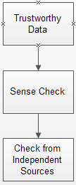
The approach exercised to quantify each technology for its current situation, is to use data from reputable sources. For example with wind, the Wind Energy Association of Ireland data was used. This would then be reviewed using independent sources i.e. the Sustainable Energy Authority of Ireland, Central Statistics office or Eirgrid (Electrical Grid Operator), where possible.
This approach was drawn upon for Wind and Biomass as there was regional data available. For data such as Geothermal and Solar (almost exclusively Thermal in Ireland) assumptions were made based on the number of private houses in the area and the percentage of houses within the BER database that have those systems.

In Figure 3-1, the flow chart methodology for producing the RES generation capacity within the region. As mentioned it is more of an ad-hoc approach depending on the data available for the RES within the region. Some data will come for the actually sources or the association with locations described. While other data will be on a national level and will have to be pro-rated down to local levels.
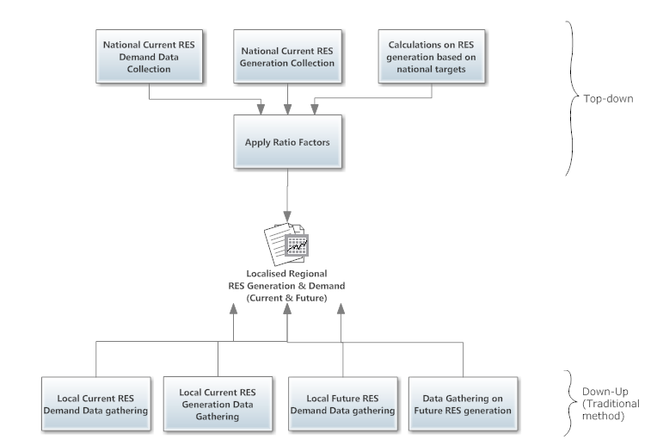
Figure 3-1 RES Generation Flowchart

Future Demand and RES Mapping Methodology

For this section, scenario and the goal of each scenario were formulated. Typically the following scenarios are usually gathered:
- Business As Usual
- Meeting Required Targets (Directive 2009/28/EC)
- Exploratory scenarios
Business as Usual: Typically means that demand will typically follow the trend, through linear regression analysis from the previous years, while RES stagnated at the current situation. It can also include policy measures legislated for up to the end of a certain period i.e. 2012 and represents a hypothetical future scenario in which no further policy actions or measures have been taken.
Meeting Required Targets: In 2007, the European Union agreed new climate and energy targets- 20-20-20 by 2020 – 20% reduction in greenhouse gas emissions by 2020; 20% energy efficiency by 2020 and 20% of the EU’s energy consumption to be from renewable sources by 2020. For this scenario each country and possible region has modelled and planned certain target of reduction for energy and growth for RES.
Exploratory scenarios: For these scenarios typically they try to examine different situations to model. Some scenarios will take an optimistic outlook and some will take a pessimistic outlook on previous scenarios.
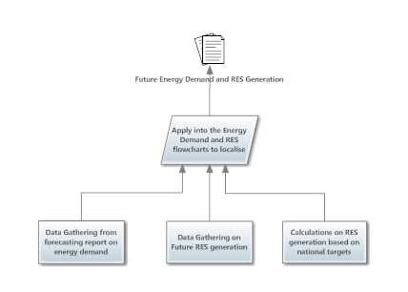
Figure 4-1 Potential Demand and Generation Flowchart

In Figure 4-2, we can see a typically criteria for evaluating some of the exploratory scenarios and the levels of details needed for each stage.
Some energy balances and RES strategy will only fulfil the first level of just theoretical recourses available. This is gross energy content of the particular form of RE or all, that occurs within a given space over time – i.e. the theoretical resource is the highest possible potential energy production from a given resource in the absence of any constraints. Some assumptions may have to be made at this stage to allow for ease of calculation of energy potential.
Technical Resource - The theoretical resource, but constrained by the efficiency of the currently available technology – i.e. the local area may have a high quality and quantity of certain resources but, if the technology to harness the resource is not mature enough and/or widely used, it may not be feasible to exploit the resource.
Practical Resource - The technical resource, but constrained by practical and physical incompatibilities – i.e. where a given resource cannot be exploited to its maximum potential due to interference with topographical and large manmade constraints and infrastructure.
Accessible Resource - The accessible resource is the practicable resource, as above, but constrained by institutional or regulatory deletions, which limit RE extraction – i.e. to determine the accessible resource, due regard to the legislation, policy and regulations will need to be taking into account.
Cost Competitive Resource - The cost-competitive/viable resource is an accessible resource that is considered to be commercially viable, the level of detail can be hard to determine and can change rapidly. The value of assessing and determining a cost-competitive/viable resource in a strategy document is questionable. Rapidly changing market conditions and the variance in developer type and capability mean that the outputs of the exercise could become rapidly obsolete and would not cover the breadth of developer types. This step is rarely implement as a high degree of uncertainty is associated with it and it can become outdated quickly.
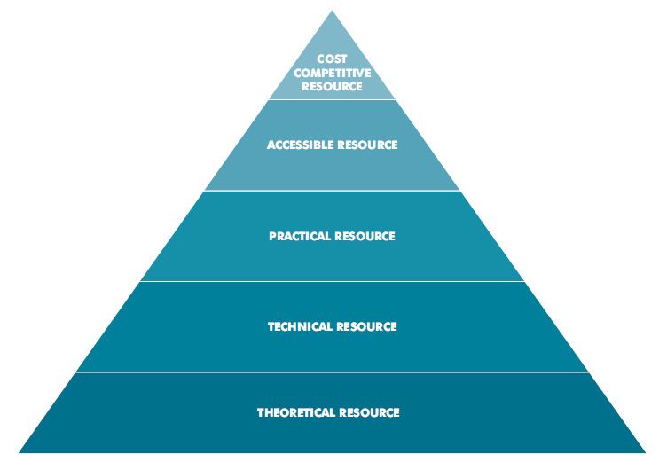
Figure 4-2 SEAI's Report for Local Authority RES strategy generation methodology (SEAI, Methodology for Local Authority Renewable Energy Strategies, June 2012)

Overall Process Flowchart
In Figure 5-1, we can see how to previously described procedures for gathering energy demand and RES generation are combined together to produce the Energy balance and RES generation for the region.
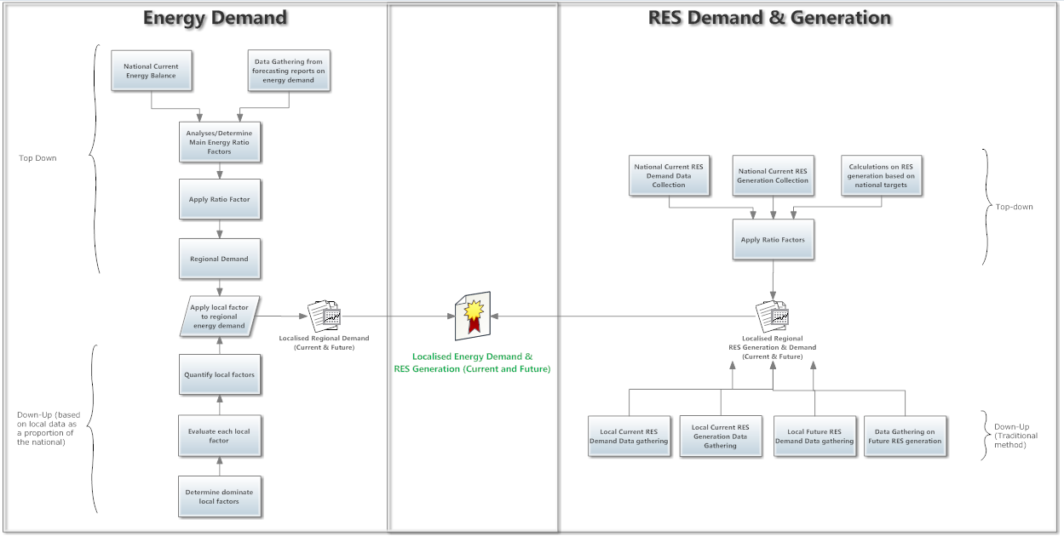
Figure 5-1 Overall Process Flowchart

Uncertainties & Data Assumption

Part of the nature of modeling and forecasting is the need to address inherently uncertain issues that have definitive impacts on the future operation of the demand and generation systems. No forecast is going to be “right” due to the fact that no one has a crystal ball regarding many of the key underlying issues, but it is extremely useful in determining directionality and cause and effect, it is more of an indicator and a certainty.
Table 6-1 depicts the typical area and examples of, what would be concerned with energy modelling.
Type of quantity | Examples | Treatment of Uncertainty
Empirical Parameters | Thermal Efficiency, fuel price | Probabilistic, parametric
Defined Constant | Emission factor | Certain by definition
Decision variable | Investment in generation, emissions cap | Parametric
Value Parameter | Discount rate, risk tolerance | Parametric
Index Variable | Time period | Certain by definition
Model domain parameter | Geographic region, time horizon, time increment | Parametric
Outcome Criterion | Net present value, utility | Determined by treatment of its inputs
Table 6-1 Identify sources of uncertainty from the perspective of the modeller (Morgan, 1992)
In scenario construction, the reference scenario assumptions are critical. These include all major variables, including the level of activity (i.e. economic growth), structural effects, and assumptions, concerning technology availability and progress.
Assumption Type | Examples
Macroeconomic and demographic assumptions | Inflation, Fuel inflation, Population growth, housing growth, employment, car ownership
energy infrastructure development | Gird upgrade, grid capacity
Technology assumptions | efficiencies, technology progression & developments
Policy | Regulations
Spatial and physical | Size of region, plant, planning restrictions
Market | Demands, Energy mix, Energy Prices
local | Aviation omitted in Tipperary as we have no airport.
Future Scenarios | Assumptions based on experience of market  * See below
Table 6-2 Assumptions Types
* Example for the solar in exploratory scenario:
- Assume that 60% of the houses in Tipperary have a south facing roof space
- Assume 60% of those would be able to afford solar thermal
- Assume 70% would be interested.

Constraints and Opportunities
This section provides the rationale for the examination and review of the constraints consideration in respect of RES – i.e. any limiting or restrictive factors that may need consideration during project development. The outcome of undertaking this constraints review, is to determine what renewable resources are viable for future development and how the barriers, to these RES, can be lessened. It is important to approach this section in an honest manner so solutions to these constraints can be found. Table 7-, gives the opportunities of RES. Both constraints and opportunities should be prioritised in terms of achievable. This can then be coupled with the RES potential within the region and will then present a beneficial focus of RES within the region.
Constraints Area | Examples
Infrastructural and Facilitators | National Electricity Grid
 | Grid Regulator connection process
 | Gas infrastructure
 | Transportation
 | District Heating
 | Telecommunication/Aviation
Environmental | Natural Heritage Sites
 | Special Areas of Protection & Special Areas of conservation
 | Landscape and Visual
 | Archaeology & Architectural
 | Tourism & Amenities
 | Cumulative & trans boundary issues
 | Odours & Noise
Financial | Initial Capital
 | Power Purchase Agreements
 | Insurance
 | Payback period
 | O/M & Fuel costs
Plant | Sizing
 | Location
 | Boundary restrictions
Technology | Technology Maturity
 | Availability
 | Reliability
 | Safety
 | Efficiency

Opportunities
Employment (Direct and Indirect)
Local Revenue and Investment
Environmental
Obligatory
Security of Supply
Carbon Credits
Less susceptible to market fluctuations
Table 7-2 Opportunities of RES

Table 7-1 Constraints of RES

Job Creation Prospects of Renewable and Sustainable Energy Technologies

A precise understanding on wider benefits arising from renewable and sustainable energy is important for decision makers whether European, National, regional or local. One of these benefits is most certainly job creation. Prior to this review it has been concluded that the literature carries a mix of methods, conversions and metrics in relation to job creation by such technologies. Poor definition of direct and indirect jobs is also prevalent in the literature (Dalton & Lewis, 2011, p2123 & Kammen et al, 2004, p2, 4 &12) and this prevents clear comparison and analysis.

Method
The literature looks at both net or gross jobs created and those authors preferring the former discount job losses in the fossil fuel industry. Such analysis is uncertain as it proves difficult to include the following effects:
- Impacts of the current recession.
- The employment rate in fossil fuel-related industries has been declining (Kammen et al, 2004, p2, 4 &12). Mechanisation normally reduces jobs in the fossil fuel industry, as in Figure 1, where since 1958 coal production increases despite reductions in jobs.
- Fossil fuel extraction rates vary greatly, in Australia, coal is extracted at an average of 13,800 tonnes per person per year while in China rates are 700 tonnes per employee per year (Greenpeace, 2009, p16 & 67).
- Since the 1900’s fossil fuel installations were subsidised and supported publically making jobs created per unit of currency invested problematic to assess.
- Since 1882, energy research and development budgets for the fossil fuel industry have been 8 times larger than for renewable energy technologies and 35 times larger than for energy efficiency end-use options (Pasicko, 2011, p4).
- Mergers of national and multinational utility companies within the conventional energy industry have produced significant lay-offs (Kammen et al, 2004, p2, 4 &12).

Given the resources available and our wish to produce robust analysis and limit uncertainty it was decided to assess gross employment figures.

Method Strands
This secondary research takes a four strand approach to calculating the employment effects of these technologies:

Strand 1: Definitions, Categorisation and Harmonisation

Definitions
A majority of authors include direct and indirect jobs and their average proportions taken from the data of Pollin & Garrett-Peltier (2009, p10) are 53% direct jobs to 47% indirect jobs.
A number of terms exist in the literature such as a job year, a person year or a full-time equivalent job (FTE) and these mean full time employment for one person for 1 year.

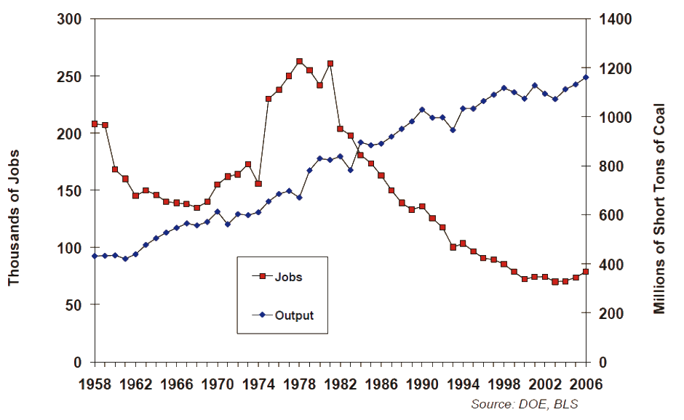
Figure 8-1Coal production and related job numbers in the USA (UNEP, 2008, p92).
A direct job is related to the installation, construction, operation and maintenance of plant and relevant works on site. An indirect job is related to the manufacture of the components of the installation (off site). Induced jobs are not usually factored into the studies reviewed and they are those created or supported by the spending of the workers with direct and indirect jobs. In line with analysis in WDC (2008, p33) and in IRBEA (2012, p19) induced jobs were estimated to be 50% larger than the direct jobs created.

Job Categorisation
Reports in the literature have categorised jobs according to manufacturing and construction (M&C), operations and maintenance (O&M) and fuel processing. Some authors reviewed ignore operations and maintenance (O&M) and fuel processing. The principal reports identified and used here refer to these three categories. In general and excepting biomass, the majority of jobs created in these industries are in M&C while those in the fossil fuel industry are in fuel processing and O&M. On first analysis this appears to disadvantage the former but deployment of such technologies is likely to be staged and given technology lifetimes of 25 to 40 years cyclic development of such installations would prevent front loading of job opportunities.

Standardising units
Studies reviewed report a variance of units and terminology with inter alia, job years, jobs/MWp (peak MW), nameplate MW, installed MW, MWa (average MW) and MWh generated. This variation makes comparison difficult so it is essential to report in harmonised employment figures. To equate the electricity and heat production from various technologies we favour the approach of Wei et al (2010) which calculates lifetime average employment per unit of energy in job years per GWh generated see Appendix I

Employment factors such as construction and installation (job-years/MWp) are thus averaged over plant lifetime to obtain an average employment number (jobs/MWp) which is added to other employment impacts such as operations and maintenance. Next, to allow for comparison between technologies with different capacity factors, we calculate employment per unit of energy generated (job-years/GWh) or per unit of MWa of power output (job-years/MWa) as in Wei et al (2010).

Strand 2: Scoping
This review was initially scoped to include 15 technologies (Appendix 2) appropriate to NWE countries. This was achieved by selecting a range of technologies for which appropriate data was available. These technologies were then reviewed by our ACE European NWE partners and revised to reflect the comments received. The table below reflects those revised technologies to which coal, nuclear, natural gas and carbon capture alternatives were added in order to provide fossil fuel benchmarks and comparison.

Technologies
Biomass | Solar PV | Carbon Capture & Storage
Geothermal | Solar Thermal | Nuclear
Landfill Gas | Wind | Coal
Hydroelectricity | Energy Efficiency | Natural Gas
Table 8-1 Chosen Technologies
Blanco and Rodrigues (2009, p2851) surveyed the wind industry and found that 59% of the direct jobs created were based in manufacture (N=328). This fraction was discounted from the jobs created here, as per objective 5, and gives a more accurate metric for the domestic jobs created by wind farm installations in Ireland (see * Table 1)

Strand 3 and 4; Methodology review and data collation
A comprehensive desk top review of academic and energy industry sources ranging from non-government organizations to universities, across Europe, North America and Canada has been conducted. Unfortunately few academic peer reviewed sources were found.

In order to provide a comprehensive assessment of the impact of these technologies on jobs it was decided to scope all potential jobs in this review incorporating direct, indirect and induced jobs. This review concluded with compilation of employment data relating to employment for renewable and sustainable energy and conventional energy installations. As mentioned the Wei et al study provided the main thrust of the approach adopted here. In addition data from other studies was evaluated increasing the reliability of the data (job years/GWh generated).

Results

Data collection
Where available production metrics were compiled for most of the technologies, and include the following:
- Installed capacity (MWp)
- Average capacity (MWa)
- Plant lifetime
- Capacity factor
- Energy generated (GWh)
- Employment (person year/job-year/FTE)
Energy Technology | Direct | Indirect | Induced jobs | Total | Average
Solar PV1 | 0.75 | 0.67 | 1.12 | 2.54 | 1.62
Solar PV2 | 0.50 | 0.45 | 0.75 | 1.70
Solar PV3 | 0.12 | 0.11 | 0.18 | 0.41
Solar PV 4 | 0.58 | 0.52 | 0.87 | 1.97
Solar PV 5 | 0.76 | 0.39 | 0.35 | 1.50
Hydroelectric 1 | 0.14 | 0.13 | 0.21 | 0.48 | 1.44
Hydroelectric 2 | - | - | - | 3.49
Hydroelectric 3 | 0.17 | 0.08 | 0.09 | 0.34
Landfill Gas 1 | 0.59 | 0.53 | 0.88 | 2.00 | 1.29
Landfill Gas 2 | 0.17 | 0.15 | 0.25 | 0.57
Offshore Wind | 0.34 | 0.31 | 0.51 | 1.16 | 1.16  *0.96
Offshore Wind* | 0.14 | 0.31 | 0.51 | 1.16
Biomass 1 | 0.12 | 0.10 | 0.17 | 0.39 | 0.61
Biomass 2 | 0.10 | 0.09 | 0.15 | 0.34
Biomass 3 | 0.26 | 0.23 | 0.39 | 0.88
Biomass 4 | 0.48 | 0.19 | 0.18 | 0.85
Onshore Wind 1 | 0.14 | 0.12 | 0.21 | 0.47 | 0.48
Onshore Wind 2 | 0.05 | 0.05 | 0.08 | 0.18 | *0.42
Onshore Wind 3 | 0.11 | 0.09 | 0.16 | 0.36
Onshore Wind 4 | 0.08 | 0.08 | 0.13 | 0.29
Onshore Wind 5 | 0.07 | 0.06 | 0.10 | 0.23
Onshore Wind 6 | 0.17 | 0.16 | 0.26 | 0.59
Onshore Wind 7 | 0.29 | 0.15 | 0.14 | 0.58
Onshore Wind 8 | 0.34 | 0.32 | 0.51 | 1.17
Geothermal 1 | 0.13 | 0.12 | 0.20 | 0.45 | 0.40
Geothermal 2 | 0.14 | 0.13 | 0.21 | 0.48
Geothermal 3 | 0.12 | 0.10 | 0.17 | 0.39
Geothermal 4 | 0.13 | 0.06 | 0.07 | 0.26
Solar Thermal 1 | 0.21 | 0.19 | 0.32 | 0.72 | 0.40
Solar Thermal 2 | 0.08 | 0.08 | 0.13 | 0.29
Solar Thermal 3 | 0.07 | 0.06 | 0.10 | 0.23
Solar Thermal 4 | 0.10 | 0.09 | 0.16 | 0.36
Energy Efficiency 1 | - | - | - | 0.36 | 0.38
Energy Efficiency 2 | - | - | - | 0.17
Energy Efficiency 3 | - | - | - | 0.59
Energy Efficiency 4 | - | - | - | 0.48
Energy Efficiency 5 | - | - | - | 0.29
Carbon Capture & Storage | 0.09 | 0.09 | 0.14 | 0.32 | 0.32
Nuclear | 0.07 | 0.07 | 0.11 | 0.25 | 0.25
Coal | 0.06 | 0.05 | 0.09 | 0.20 | 0.20
Natural Gas | 0.06 | 0.05 | 0.09 | 0.20 | 0.20
Table 8-2 Ranked job creation estimates (job-years/GWh) for renewable and sustainable energy technologies
A short version of the resultant conversions is presented in Table 8-2. While a complete version can be found in Appendix III. The job estimate for offshore wind in Table 8-2 is 1.16 job-years/GWh and is referenced in just one study. Another 8 studies presented a mix of offshore and onshore job creation data. The data from these 8 reports is taken and averaged at 0.48 job years/GWh or 0.42*(domestic) job-years/GWh. The latter focuses on those jobs created in Ireland by investment in wind and attempts to exclude the manufacturing jobs created in other countries.

Job Creation Conclusions
This section has enabled an assessment to be made of the overall impacts of renewables and sustainable energy technologies on employment in Tipperary in Ireland and in ACE partner countries. It is a synthesis of existing studies and can support scenario analysis and assist policy makers in answering the employment consequences of renewable and sustainable energy investment. Like other studies, Table 1 shows that such investment generates more jobs per unit energy than fossil fuel alternatives. It can be seen for example that investment in Solar PV yields 8 times more jobs per unit energy than investment in gas. This employment increase occurs because:
- Renewable energy production and sustainable energy technologies are more labour intensive,
- And they require less imported technology.

Table 8-2 clearly points the way for countries with high solar exposure while waste treatment at landfill would appear to be a favourable technology where capacity exists. Offshore wind farms and biomass offer strong job creation prospects dependent only on resources. In general investing in biomass installations offers 50% more jobs than wind (0.42), solar thermal (0.40) and geothermal (0.40) installations. In preference to replacement of retired fossil fuel plants it would appear that investment in energy efficiency upgrades would have strong economic impacts as such investment creates 90% more jobs per unit of energy saved/produced.
This analysis relies on references authored over 11 years and has thus captured impacts of technological innovation over this period. Variation of jobs generated for equivalent technologies differs within studies and presents an inconsistency and the range of job per energy unit difference is large. Earlier studies often estimated lower job generation figures and this appears inconsistent with the tenet that increased innovation and mechanisation reduces employment.

Recommendations
Based on the prioritised list of constraints and opportunities especially local job opportunities in section 7 and 8 and also the RES potential within the area, a set of recommendations can accompany the demand and resource potential for the region, this can give a set of achievable and desirable goals and objectives, for within a certain timeline for the region.

References
CSO. (2012). Persons aged 15 years and over at work (excluding those who work mainly at or from home), usually resident and present in the State on census night, classified by time taken to travel to work and province, county and city of usual residence . Retrieved from Central Statistics Office: http://www.cso.ie/px/pxeirestat/Statire/SelectVarVal/Define.asp?maintable=CD014&PLanguage=0
Dept.Transport. (2011). Dept. of Transport, Tourism and Sport. Retrieved from Irish Bulletin of Vehicle Dirver Statisitcs 2011: http://www.transport.ie/roads/reports/index.asp?loc=397
Löschel, A. (2002). Technological change in economic models of environmental policy survey. Ecological Economics, 43 (2002), pp. 105–126.
Morgan, M. G. (1992). Uncertainty: A guide to dealing with uncertainty in Quantitative Risk and Policy Analysis. Cambridge University Press.
SEAI. (2012). Sustianable Energy Authority of Ireland. Retrieved from National BER Research Tool: http://www.seai.ie/Your_Building/BER/National_BER_Research_Tool/
SEAI. (June 2012). Methodology for Local Authority Renewable Energy Strategies.
Blanco, M., I. & Rodrigues, G., 2009. Direct Employment in the Wind Energy Sector: An EU study. Energy Policy, 37, 2847–2857.
Blue Green Canada, 2012. More Bang for your Buck – How Canada can Create More Energy Jobs and Less Pollution. Blue Green Canada, Ontario, Canada.
Dalton, G.J. & Lewis, T., 2011. Metrics for Measuring Job Creation by Renewable Energy Technologies, Using Ireland as a Case Study. Renewable and Sustainable Energy Reviews, 15, 2123-2133.
Electric Power Research Institute (EPRI) and California Energy Commission (CEC), 2001. California Renewable Technology Market and Benefits Assessment. EPRI 100119, Palo Alto,CA and Sacramento, California.
European Photovoltaic Industry Association (EPIA), 2006. Solar Generation: Solar Electricity for Over One Billion People and Two Million Jobs by 2020. European Photovoltaic Industry Association, Brussels.
European Renewable Energy Council (EREC), 2009. Working for the Climate – Renewable Energy and the Green Job Revolution. Greenpeace International, Amsterdam.
European Wind Energy Association (EWEA), 2009. Wind at Work: Wind Energy and Job Creation in the EU. European Wind Energy Association, Brussels.
Friedmann, J., 2009. Carbon capture and storage job impacts. Personal communication as reported in Wei et al, 2010.
Greenpeace, 2009. Working for the Climate; Renewable Energy and the Green Job Revolution. Greenpeace International, Amsterdam, Netherlands.
Heavner, B. & Churchill, S., 2002. Renewables Work: Job Growth from Renewable Energy Development in California. CALPIRG Charitable Trust, University of California-Berkeley, California.
Irish Bio-Energy Association (IRBEA), 2012. The Economic Benefits from the Development of BioEnergy in Ireland to meet 2020 Targets. IRBEA, Clonmel, Tipperary.
Jochem, E. & Madlener, R., 2003. The Forgotten Benefits of Climate Change Mitigation; Innovation, Technological Leapfrogging, Employment and Sustainable Development. OECD, Paris, France.
Kammen, D.M., Kapadia, K. & Fripp, M., 2004. Putting renewables to work: how many jobs can the clean energy industry generate? RAEL Report, University of California, Berkeley.
Kenley, C.R., Klingler, R.D., Plowman, C.M., Soto, R., Turk, R.J., Baker, R.L., Close, S.A., McDonnell, V.L., Paul, S.W., Rabideau, L.R., Rao, S.S. & Reilly, B.P., 2004. U.S. Job Creation Due to Nuclear Power Resurgence in the United States, V. 1 & 2. Idaho National Engineering and Environmental Laboratory and Bechtel BWXT, Idaho.
Laitner, J.A., McKinney, V., 2008. Positive Returns: State Energy Efficiency Analyses Can Inform U.S. Energy Policy Assessments. American Council for an Energy Efficient Economy, Washington.
McKinsey Consulting, 2006. Wind, Oil and Gas: The Potential of Wind. McKinsey and Company, Washington.
Pasicko, R., 2011. Green Development Prospects for Green Jobs, Investments and Emission Reduction. Environmental Governance Programme, UNDP, Croatia.
Pollin, R. & Garrett-Peltier, H., 2009. Building the Green Economy: Employment Effects of Green Energy Investments for Ontario. Blue Green Canada, Canada.
Singh, V. & Fehrs, J., 2001. The Work that Goes into Renewable Energy. Renewable Energy Policy Project Research Report No. 13, Renewable Energy Policy Project, Washington, DC.
SkyFuels and National Renewable Energy Laboratory, 2009. Solar thermal jobs data. Personal communication as reported in Wei et al, 2010.
Sterzinger, G., 2006. Jobs and Renewable Energy Project. Renewable Energy Policy Project, Washington.
Stoddard, L., Abiecunas, J, & O'Connell, R., 2006. Economic, Energy, and Environmental Benefits of Concentrating Solar Power in California. National Renewable Energy Laboratory, Golden, Colorado.
Tourkoliasa, C. & Mirasgedisb, S., 2011. Quantification and Monetization of Employment Benefits Associated with Renewable Energy Technologies in Greece. Renewable and Sustainable Energy Reviews, 15, 2876– 2886.
United Nations Environmental Programme (UNEP), 2008. Green Jobs: Towards Decent Work in a Sustainable, Low-Carbon World. UNEP, Nairobi, Kenya.
WDC, 2008. Biomass CHP Market Potential in the Western Region: An Assessment. Western Development Commission, Roscommon, Ireland.
Wei, M., Patadia, S. & Kammen, D.M., 2010. Putting renewables and energy efficiency to work: How many jobs can the clean energy industry generate in the US? Energy Policy, 38, 919–931.
Western Development Commission (WDC), 2008. Biomass CHP - Market Potential in the Western Region: An Assessment. WDC, Ballaghaderreen, Roscommon.
Western Governors’ Association, 2005. Geothermal Task Force Report, Clean and Diversified Energy Initiative. Denver, Colorado.

Appendix I

A 228MW (35% capacity factor) wind installation creates 500 C&M jobs over 5 years (2,500 job-years) and 40 O&M jobs over 20 years (800 job-years) (Wei et al (2010, p923).
Presuming the plant lifetime is 25 years:
C&M: 2500/(228*25*0.35) = 1.25 jobs per MWa
O&M: 800/(228*25*0.35) = 0.40 jobs per MWa

Appendix II

1. Large scale Wind power (+50kW)
2. Small scale wind power (up to 50kW)
3. Tidal Power
4. Wave Power
5. Solar PV
6. Solar thermal
7. Hydroelectricity
8. Geothermal Heating
9. Biomass
10. Biogas
11. Biofuel
12. Domestic Retrofit
13. Deep Retrofit (Passive House standard perhaps)
15. Electric Vehicles

Appendix III

Energy Technology | Study | capacity factor | Life time | C&M | O&M | fuel extraction processing | C&M | O/M &fuel | C&M | O/M &fuel | C&M | O/M &fuel | Total | Average
 |  | % | years | Job years  /MWp | Jobs/MWp | Job years/ GWh | ∑Jobs/ MWp | ∑Jobs/ MWp | ∑Jobs/ MWa | ∑Jobs/ MWp | ∑Jobs years/ GWh | ∑Jobs years/ GWh
Biomass 1 | EPRI 2001 | 85 | 40 | 4.29 | 1.53 | 0.00 | 0.11 | 1.53 | 0.13 | 1.80 | 0.01 | 0.21 | 0.22 | 0.30
Biomass 2 | REPP 2001 | 85 | 40 | 8.50 | 0.24 | 0.13 | 0.21 | 1.21 | 0.25 | 1.42 | 0.03 | 0.16 | 0.19
Biomass electric | Greenpeace, 2009 | 85 | 40 | 4.30 | 3.10 | 0.07 | 0.11 | 3.59 | 0.13 | 4.21 | 0.02 | 0.47 | 0.49
Biomass | Tourkolias & Mirasgedis, 2011
Geothermal | WGA 2005 | 90 | 40 | 6.43 | 1.79 | 0.00 | 0.16 | 1.79 | 0.18 | 1.98 | 0.02 | 0.23 | 0.25 | 0.25
Geothermal | CALPIRG 2002 | 90 | 40 | 17.50 | 1.70 | 0.00 | 0.44 | 1.70 | 0.49 | 1.89 | 0.06 | 0.22 | 0.27
Geothermal | EPRI 2001 | 90 | 40 | 4.00 | 1.67 | 0.00 | 0.10 | 1.67 | 0.11 | 1.86 | 0.01 | 0.21 | 0.22
Geothermal | Tourkolias & Mirasgedis, 2011
Landfill Gas 1 | CALPIRG, 2002 | 85 | 40 | 21.30 | 7.80 | 0.00 | 0.53 | 7.80 | 0.63 | 9.18 | 0.07 | 1.05 | 1.12 | 0.72
Landfill Gas 2 | EPRI 2001 | 85 | 40 | 3.71 | 2.28 | 0.00 | 0.09 | 2.28 | 0.11 | 2.68 | 0.01 | 0.31 | 0.32
Small Hydro | EPRI 2001 | 55 | 40 | 5.71 | 1.14 | 0.00 | 0.14 | 1.14 | 0.26 | 2.07 | 0.03 | 0.24 | 0.27 | 0.27
Hydro | Bluegreen, 2012 & Greenpeace, 2009 |  |  | 11.30 | 0.22
Hydro | Tourkolias & Mirasgedis, 2011
Solar PV1 | EPIA/Greenpeace, 2006 | 20 | 25 | 37.00 | 1.00 | 0.00 | 1.48 | 1.00 | 7.40 | 5.00 | 0.84 | 0.57 | 1.42 | 0.92
Solar PV2 | REPP 2006 | 20 | 25 | 32.34 | 0.37 | 0.00 | 1.29 | 0.37 | 6.47 | 1.85 | 0.74 | 0.21 | 0.95
Solar PV3 | EPRI 2001 | 20 | 25 | 7.14 | 0.12 | 0.00 | 0.29 | 0.12 | 1.43 | 0.60 | 0.16 | 0.07 | 0.23
Solar PV | Greenpeace, 2009 | 20 | 25 | 38.40 | 0.40 | 0.00 | 1.54 | 0.40 | 7.68 | 2.00 | 0.87 | 0.23 | 1.10
Solar PV | Tourkolias & Mirasgedis, 2011
Solar Thermal 1 | Skyfuels/NREL, 2009 | 40 | 25 | 10.31 | 1.00 | 0.00 | 0.41 | 1.00 | 1.03 | 2.50 | 0.12 | 0.29 | 0.40 | 0.23
Solar Thermal 2 | NREL, 2006 | 40 | 25 | 4.50 | 0.38 | 0.00 | 0.18 | 0.38 | 0.45 | 0.95 | 0.05 | 0.11 | 0.16
Solar Thermal 3 | EPRI, 2001 | 40 | 25 | 5.71 | 0.22 | 0.00 | 0.23 | 0.22 | 0.57 | 0.55 | 0.07 | 0.06 | 0.13
Solar Termal | Greenpeace, 2009 | 40 | 25 | 10.00 | 0.30 | 0.00 | 0.40 | 0.30 | 1.00 | 0.75 | 0.11 | 0.09 | 0.20
Wind 1 EW | EWEA 2008 | 35 | 25 | 10.10 | 0.40 | 0.00 | 0.40 | 0.40 | 1.15 | 1.14 | 0.13 | 0.13 | 0.26 | 0.20
Wind 2 RE | REPP 2006 | 35 | 25 | 3.80 | 0.14 | 0.00 | 0.15 | 0.14 | 0.43 | 0.41 | 0.05 | 0.05 | 0.10
Wind 3 Mc | McKinsey, 2006 | 35 | 25 | 10.96 | 0.18 | 0.00 | 0.44 | 0.18 | 1.25 | 0.50 | 0.14 | 0.06 | 0.20
Wind 4 CA | CALPIRG, 2002 | 35 | 25 | 7.40 | 0.20 | 0.00 | 0.30 | 0.20 | 0.85 | 0.57 | 0.10 | 0.07 | 0.16
Wind 5 EP | EPRI 2001 | 35 | 25 | 2.57 | 0.29 | 0.00 | 0.10 | 0.29 | 0.29 | 0.83 | 0.03 | 0.09 | 0.13
Wind on | Greenpeace, 2009 | 35 | 25 | 15.40 | 0.40 | 0.00 | 0.62 | 0.40 | 1.76 | 1.14 | 0.20 | 0.13 | 0.33
Wind off | Greenpeace, 2009 | 35 | 25 | 28.80 | 0.77 | 0.00 | 1.15 | 0.77 | 3.29 | 2.20 | 0.38 | 0.27 | 0.65
Wind (on) | Bluegreen, 2012
Wind | Tourkolias & Mirasgedis, 2011
Carbon Capture & Storage | Friedmann, 2009 | 80 | 40 | 20.48 | 0.31 | 0.06 | 0.51 | 0.73 | 0.64 | 0.91 | 0.07 | 0.10 | 0.18 | 0.18
Nuclear I | INEEL 2004 | 90 | 40 | 15.20 | 0.70 | 0.00 | 0.38 | 0.70 | 0.42 | 0.78 | 0.05 | 0.09 | 0.14 | 0.14
Coal REPP | REP2001 | 80 | 40 | 8.50 | 0.18 | 0.06 | 0.21 | 0.59 | 0.27 | 0.74 | 0.03 | 0.08 | 0.11 | 0.11
Natural Gas | CALPIRG, 2002 | 85 | 40 | 1.02 | 0.10 | 0.09 | 0.03 | 0.77 | 0.03 | 0.91 | 0.00 | 0.10 | 0.11 | 0.11
Energy Efficiency | Jochim & Madlener, 2003, pg 18
Energy Efficiency | ACEEE, 2008 | 100 | 20 |  |  |  |  |  |  |  |  |  | 0.17 | 0.38
Energy Efficiency | Goldemberg, 2008 | 100 | 20 |  |  |  |  |  |  |  |  |  | 0.59
Energy Efficiency | Bluegreen, 2012
Energy Efficiency | Greenpeace, 2009

Energy Technology | Study | Direct |  | Indirect |  | Induced jobs |  | Total (d+i+i) |  | Average
Biomass 1 | EPRI 2001 | 0.12 |  | 0.10 |  | 0.17 |  | 0.39 |  | 0.61
Biomass 2 | REPP 2001 | 0.10 |  | 0.09 |  | 0.15 |  | 0.34
Biomass electric | Greenpeace, 2009 | 0.26 |  | 0.23 |  | 0.39 |  | 0.88
Biomass | Tourkolias & Mirasgedis, 2011 | 0.48 |  | 0.19 |  | 0.18 |  | 0.85
Geothermal | WGA 2005 | 0.13 |  | 0.12 |  | 0.20 |  | 0.45 |  | 0.40
Geothermal | CALPIRG 2002 | 0.14 |  | 0.13 |  | 0.21 |  | 0.48
Geothermal | EPRI 2001 | 0.12 |  | 0.10 |  | 0.17 |  | 0.39
Geothermal | Tourkolias & Mirasgedis, 2011 | 0.13 |  | 0.06 |  | 0.07 |  | 0.26
Landfill Gas 1 | CALPIRG, 2002 | 0.59 |  | 0.53 |  | 0.88 |  | 2.00 |  | 1.29
Landfill Gas 2 | EPRI 2001 | 0.17 |  | 0.15 |  | 0.25 |  | 0.57
Small Hydro | EPRI 2001 | 0.14 |  | 0.13 |  | 0.21 |  | 0.48 |  | 1.44
Hydro | Bluegreen, 2012 & Greenpeace, 2009 |  |  |  |  |  |  | 3.49
Hydro | Tourkolias & Mirasgedis, 2011 | 0.17 |  | 0.08 |  | 0.09 |  | 0.34
Solar PV1 | EPIA/Greenpeace, 2006 | 0.75 |  | 0.67 |  | 1.12 |  | 2.54 |  | 1.62
Solar PV2 | REPP 2006 | 0.50 |  | 0.45 |  | 0.75 |  | 1.70
Solar PV3 | EPRI 2001 | 0.12 |  | 0.11 |  | 0.18 |  | 0.41
Solar PV | Greenpeace, 2009 | 0.58 |  | 0.52 |  | 0.87 |  | 1.97
Solar PV | Tourkolias & Mirasgedis, 2011 | 0.76 |  | 0.39 |  | 0.35 |  | 1.50
Solar Thermal 1 | Skyfuels/NREL, 2009 | 0.21 |  | 0.19 |  | 0.32 |  | 0.72 |  | 0.40
Solar Thermal 2 | NREL, 2006 | 0.08 |  | 0.08 |  | 0.13 |  | 0.29
Solar Thermal 3 | EPRI, 2001 | 0.07 |  | 0.06 |  | 0.10 |  | 0.23
Solar Termal | Greenpeace, 2009 | 0.10 |  | 0.09 |  | 0.16 |  | 0.36
Wind 1 EW | EWEA 2008 | 0.14 |  | 0.12 |  | 0.21 |  | 0.47 |  | 0.48
Wind 2 RE | REPP 2006 | 0.05 |  | 0.05 |  | 0.08 |  | 0.18 |  | 0.42
Wind 3 Mc | McKinsey, 2006 | 0.11 |  | 0.09 |  | 0.16 |  | 0.36
Wind 4 CA | CALPIRG, 2002 | 0.08 |  | 0.08 |  | 0.13 |  | 0.29
Wind 5 EP | EPRI 2001 | 0.07 |  | 0.06 |  | 0.10 |  | 0.23
Wind on | Greenpeace, 2009 | 0.17 |  | 0.16 |  | 0.26 |  | 0.59
Wind off | Greenpeace, 2009 | 0.34 |  | 0.31 |  | 0.51 |  | 1.16
Wind (on) | Bluegreen, 2012 | 0.34 |  | 0.32 |  | 0.51 |  | 1.17
Wind | Tourkolias & Mirasgedis, 2011 | 0.29 |  |  | 0.15 |  | 0.14 |  | 0.58
Carbon Capture & Storage | Friedmann, 2009 | 0.09 |  |  | 0.09 |  | 0.14 |  | 0.32 |  | 0.32
Nuclear I | INEEL 2004 | 0.07 |  |  | 0.07 |  | 0.11 |  | 0.25 |  | 0.25
Coal REPP | REP2001 | 0.06 |  |  | 0.05 |  | 0.09 |  | 0.20 |  | 0.20
Natural Gas | CALPIRG, 2002 | 0.06 |  |  | 0.05 |  | 0.09 |  | 0.20 |  | 0.20
Energy Efficiency | Jochim & Madlener, 2003, pg 18 |  |  |  |  |  |  |  | 0.36 |  | 0.38
Energy Efficiency | ACEEE, 2008 |  |  |  |  |  |  |  | 0.17
Energy Efficiency | Goldemberg, 2008 |  |  |  |  |  |  |  | 0.59
Energy Efficiency | Bluegreen, 2012 |  |  |  |  |  |  |  | 0.48
Energy Efficiency | Greenpeace, 2009 |  |  |  |  |  |  |  | 0.29

